- PPS Database System – Ticketing Tool Changes: (View change)
- Changes in the PPS Ticketing System
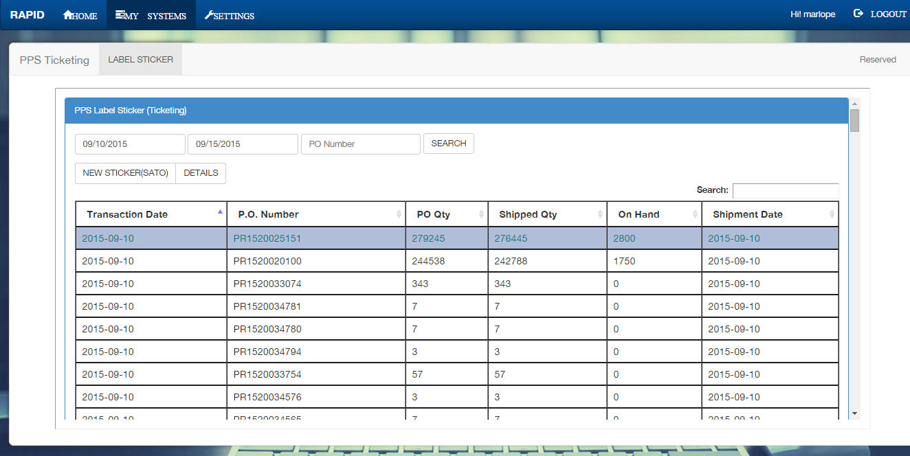
- Viewing of every transaction on ticketing is also available by selecting a record then press the details button. Also user have an option to delete a ticketing transaction (see delete procedure below). 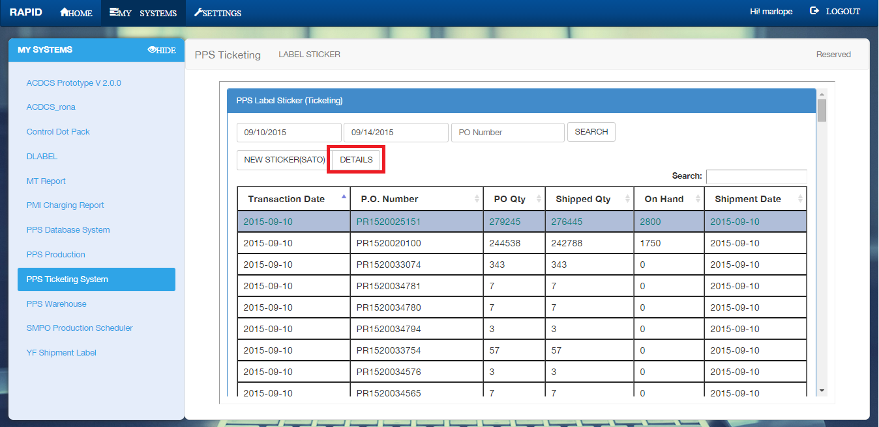
- Transaction Details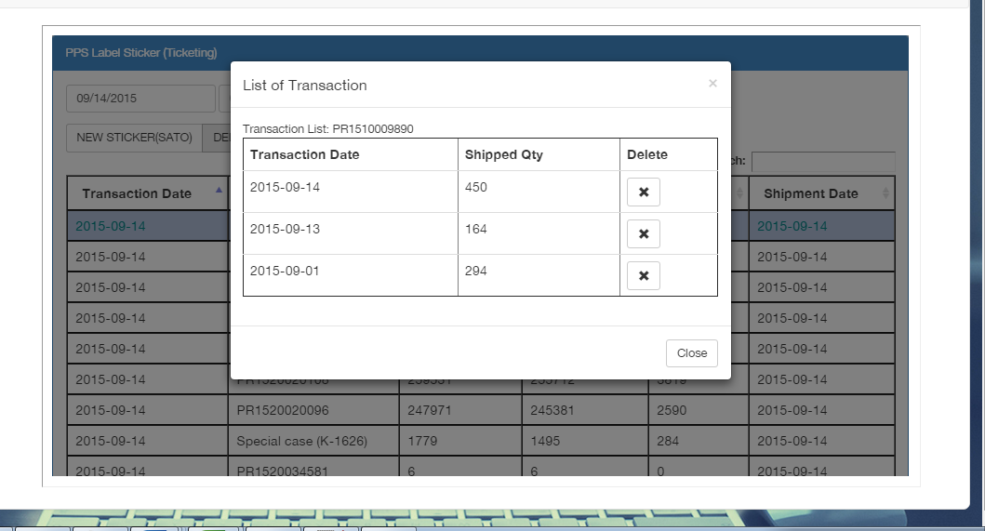

- PPS Database System – Ticketing Tool Changes: (Transaction Delete) Deletion of ticketing transaction will be useful in case the user encounter an error during printing.

- Select a PO Number from the list, you can do this by clicking the row of the selected record. 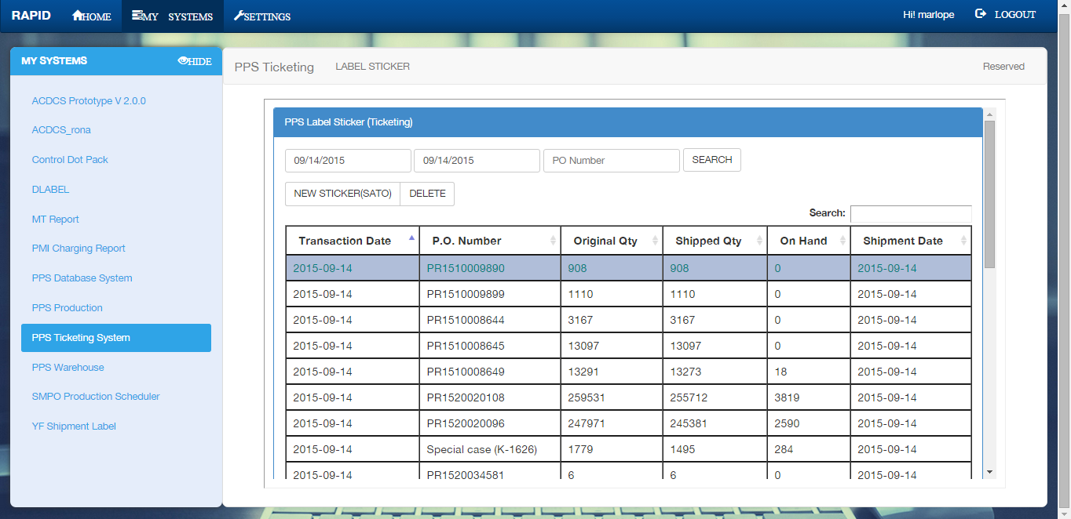
- Press the Details button
- A dialog box will appear, Dialog box contains all the transaction made on the selected PO.
- Delete the transaction that you want to delete.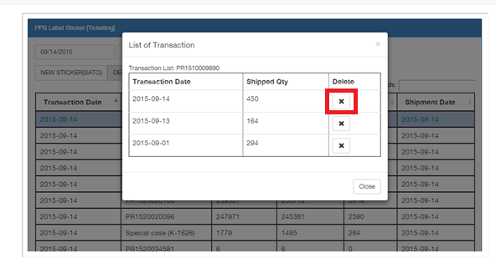
- A message box will appear press ok to continue or cancel. 

